Guide to ASW Extraction using Jar file

Contents

1. Start the ASW Extract tool using the jar file 1

2. Get past help tips 2

3. Enter source database connection information 2

4. Select / Enter information to be extracted. 4

4.1 Select the appropriate module 4

4.2 Select the appropriate table 5

4.3 Select a target folder 7

4.4 Enter the PK ID 7

4.5 Other fields 8

4.6 Click Go and wait till the file gets exported 9

5. Watch for the confirmation that the file was written successfully. 11

6. Locate the file and verify the contents of the file. 12

# Start the ASW Extract tool using the jar file

java -jar ASWExtract-0.0.1-SNAPSHOT-jar-with-dependencies.jar

# Get past help tips

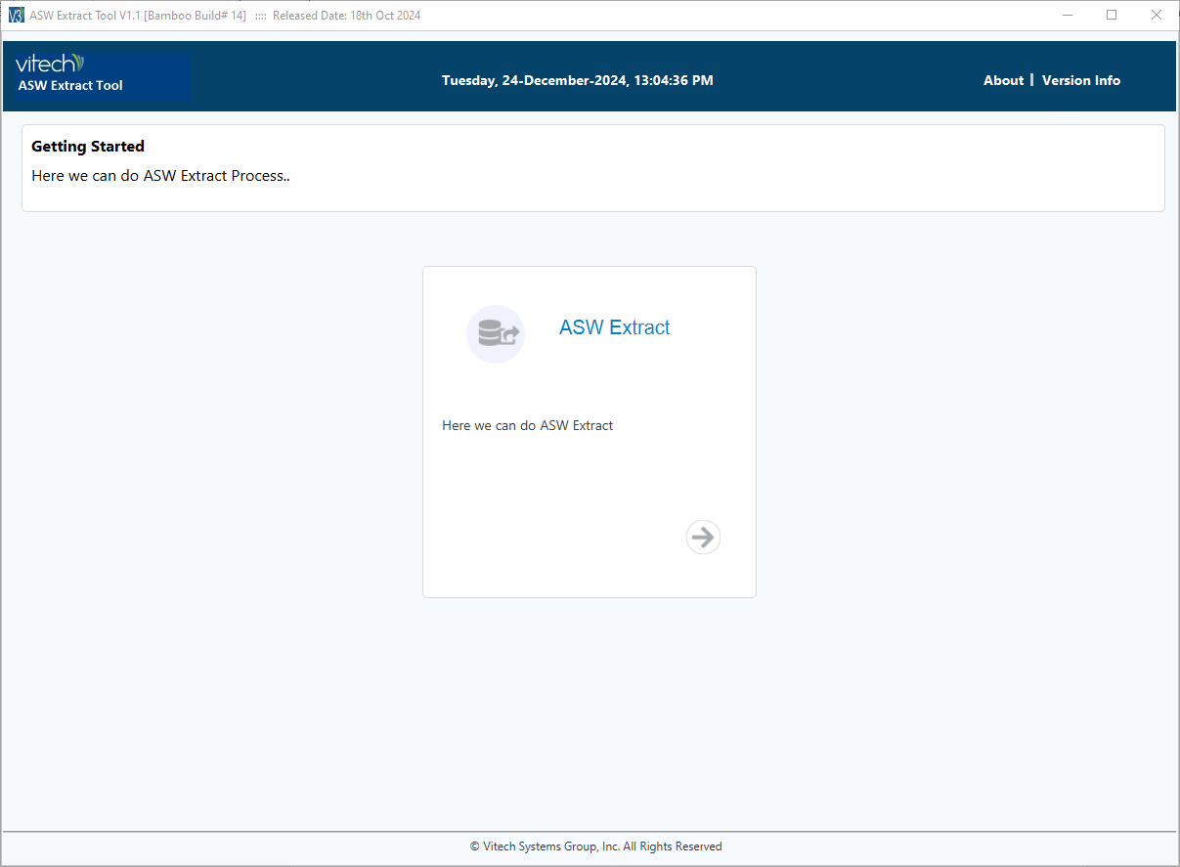

# Enter source database connection information

Host: Address of the RDS Cluster

Database: Name of the database

Port: 5432

Username: db username

Password: db password

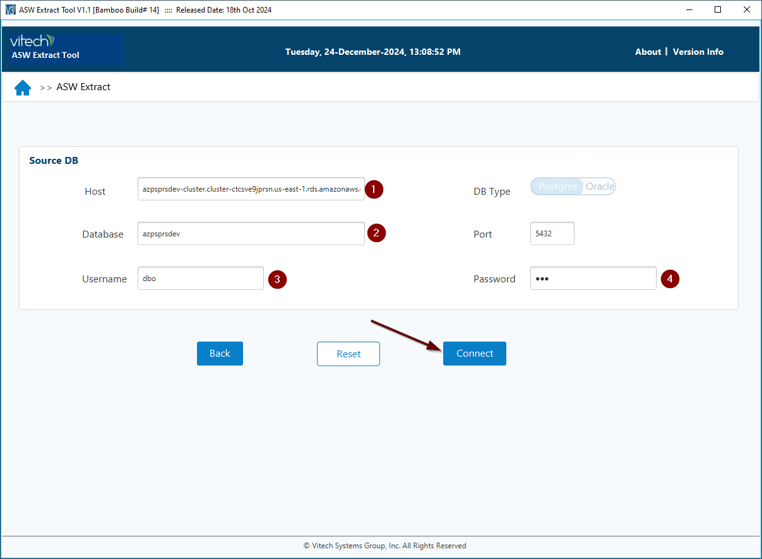

# Select / Enter information to be extracted.

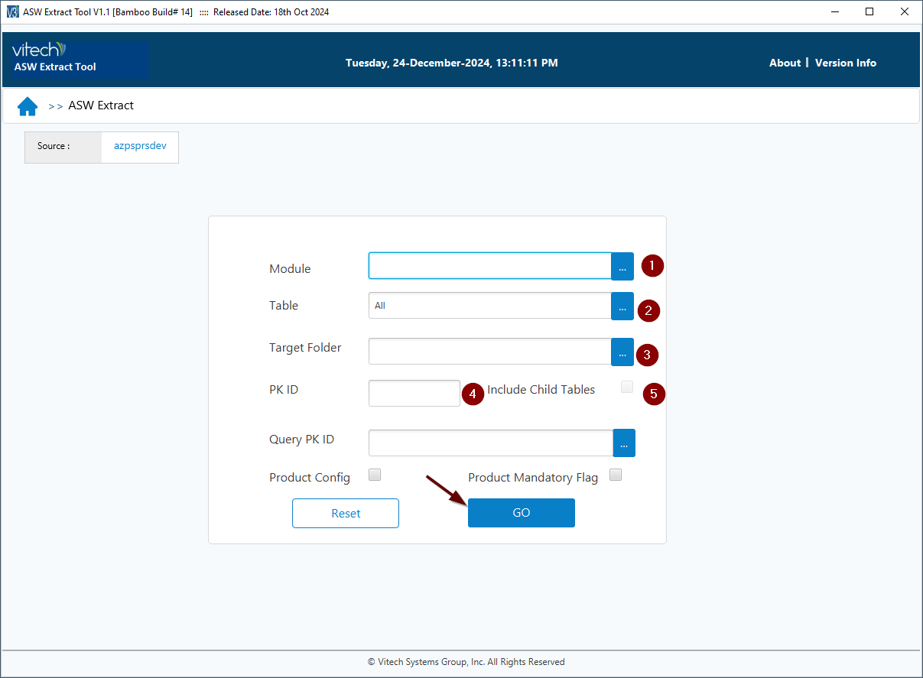

## 4.1 Select the appropriate module

Click on the button with … next to the Module text field

DOCUMENT for Documents

QUERY for Queries

Select the module from Available Modules and use the arrow button to move it to the Selected Modules

Click Save

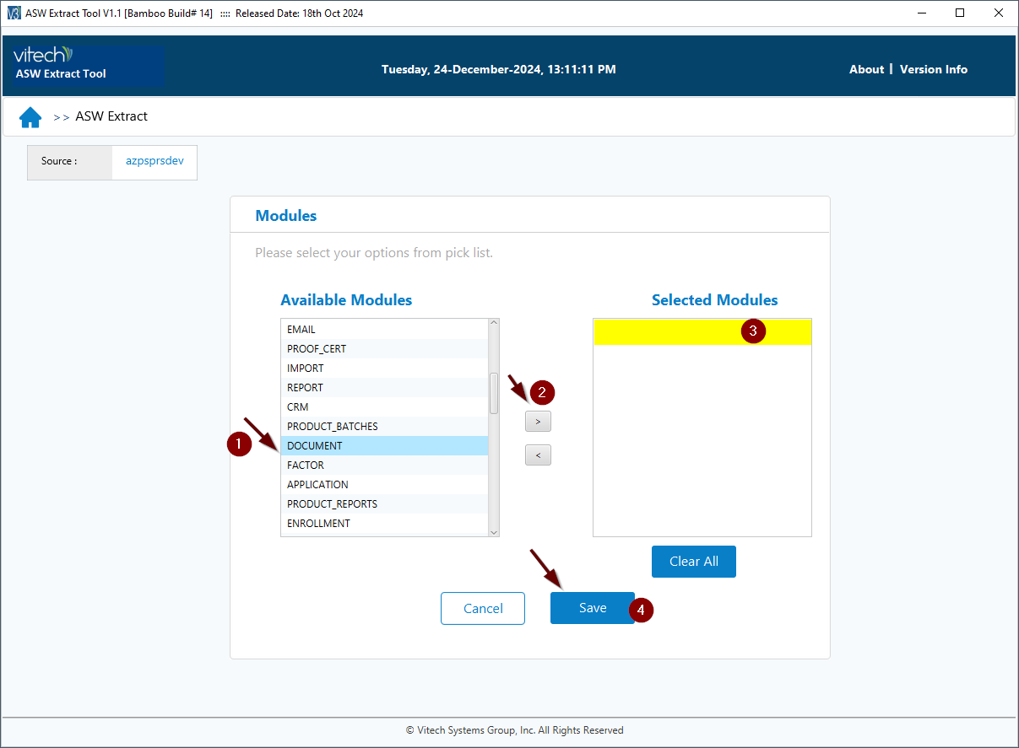

## 4.2 Select the appropriate table

Click on the button with … next to the Table text field

DOC_SHELL for Documents

QUERY for Queries

Select the table from “Available Tables” and use the arrow button to move it to the Selected Tables

Click Save

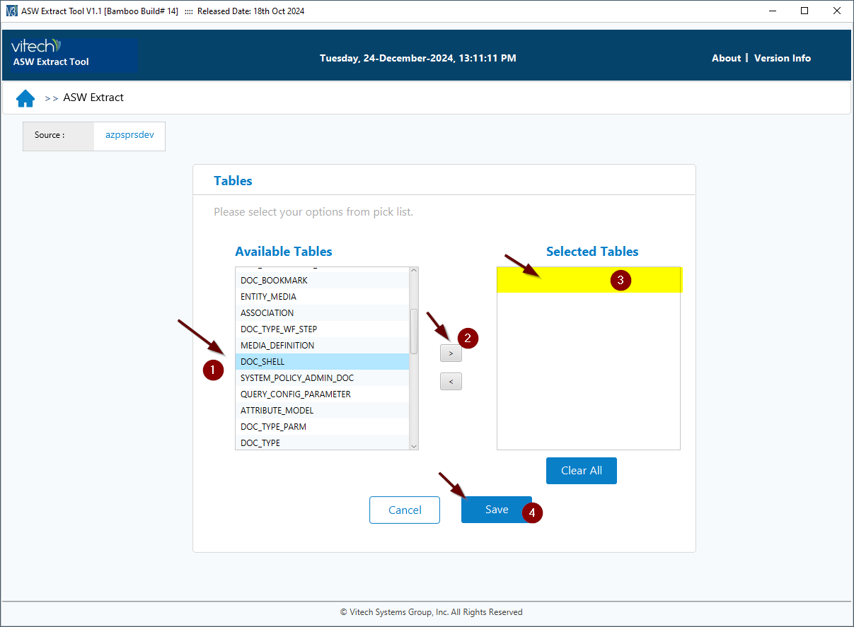

Query Example:

## 4.3 Select a target folder

This can be any directory on the computer, the generated ASW file will be stored at this location.

## 4.4 Enter the PK ID

PK ID is the primary key value of the artifact (document or query) that is to be extracted.

**PK ID for a document**

Use the below query to find the pk id of the document

**Query**

select doc_shell_id from dbo .doc_shell where doc_shell_name ='<document name>' and current_version ='Y' and published ='Y'

**Example:**

select doc_shell_id from dbo .doc_shell where doc_shell_name ='DOC_SHELL_7DAFBFEF-5E22-46B5-B994-52CDE47BB518' and current_version ='Y' and published ='Y';

**PK ID for a query**

Use the below query to find the pk id of the document

**Query:**

select query_id from dbo.query where  display_name =’<display name of the query>';

**Example:**

select query_id from dbo.query where  display_name ='dl031 new disability letter';

## 4.5 Other fields

Leave Query PK Id empty, product config and product mandatory flags unchecked.

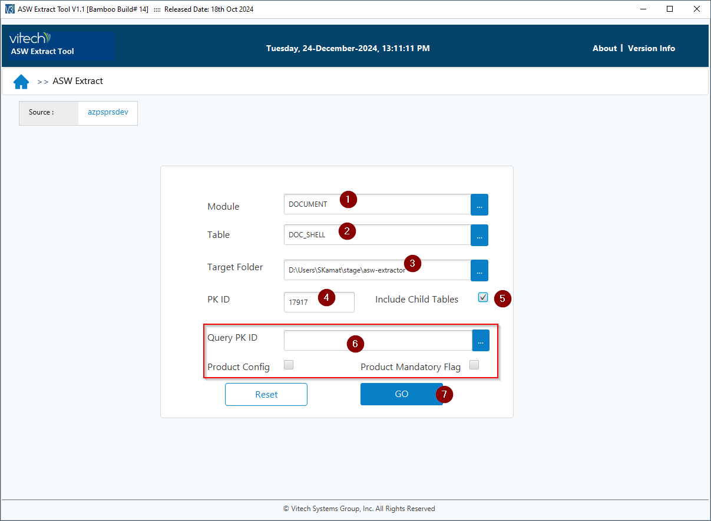

## 4.6 Click Go and wait till the file gets exported

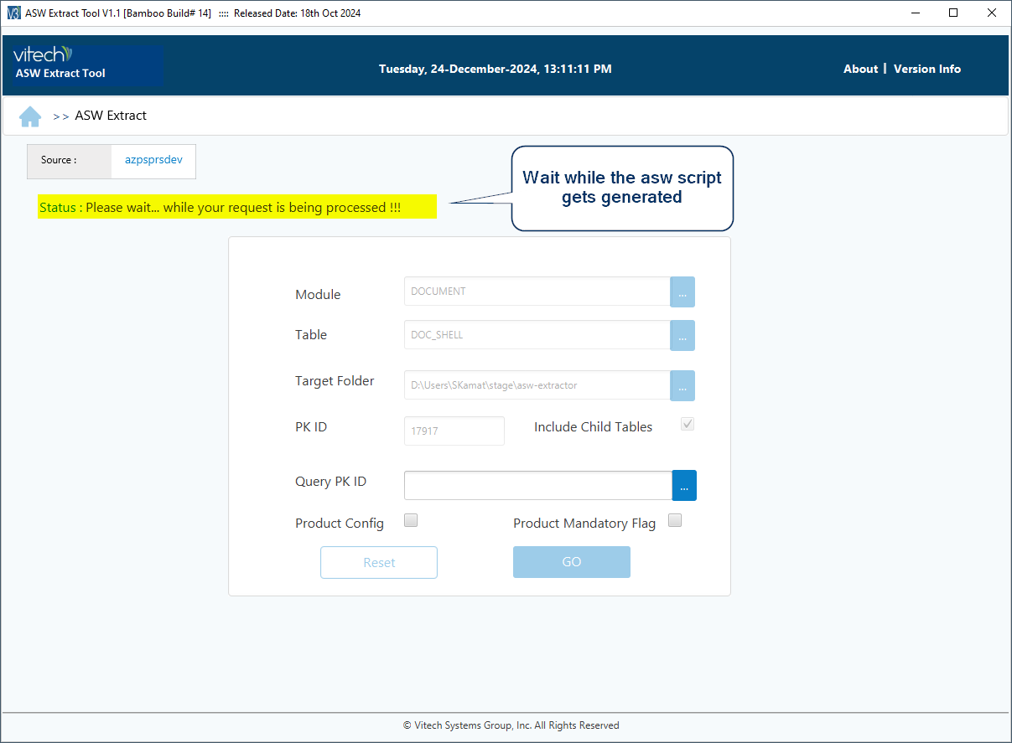

# Watch for the confirmation that the file was written successfully.

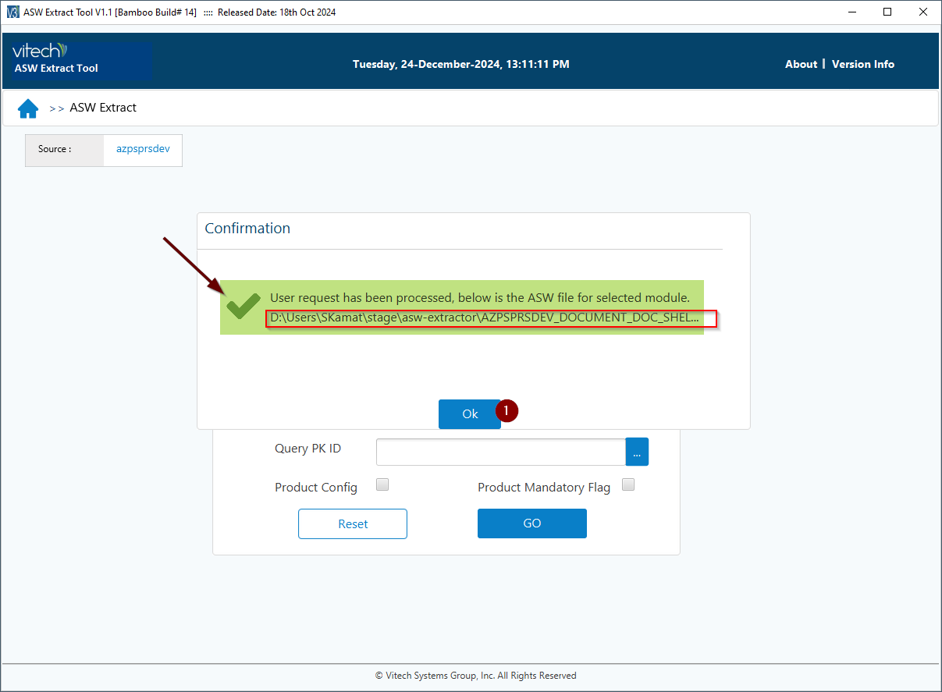

# Locate the file and verify the contents of the file.

